Unit 1 | Assignment - KickStart My Chart

What are three conclusions we can make about Kickstarter campaigns given the provided data?

1. There are more Kickstarter campaigns in the arts category than any other category and they have also had the highest success.
2. Theater has been the most frequent type of Kickstarter campaign, and it has also had the most success.
3. 2015 was the biggest year for Kickstarter campaigns. The first 3 years Kickstarter had the lowest number of accounts.

What are some of the limitations of this dataset? There isn’t enough information to give us visibility to define the reasons that led to so many unsuccessful Kickstarter campaigns. What are the pressure point’s that either make or break an individual’s Kickstarter campaigns success?

What are some other possible tables/graphs that we could create?

* Histogram - Historical Trends of year over year.
* Scatter Plot - So we can see which categories had the most people’s financial backing Kickstarter campaigns.
* Pie Chart - Top 10% of successful Kickstarter categories and which 10% categories were cancelled and failed overall.

Chart 1

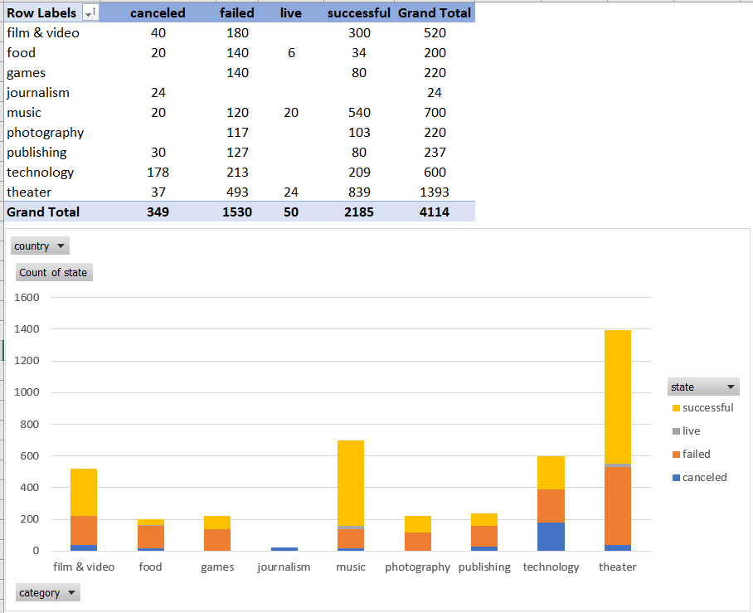

Chart 2

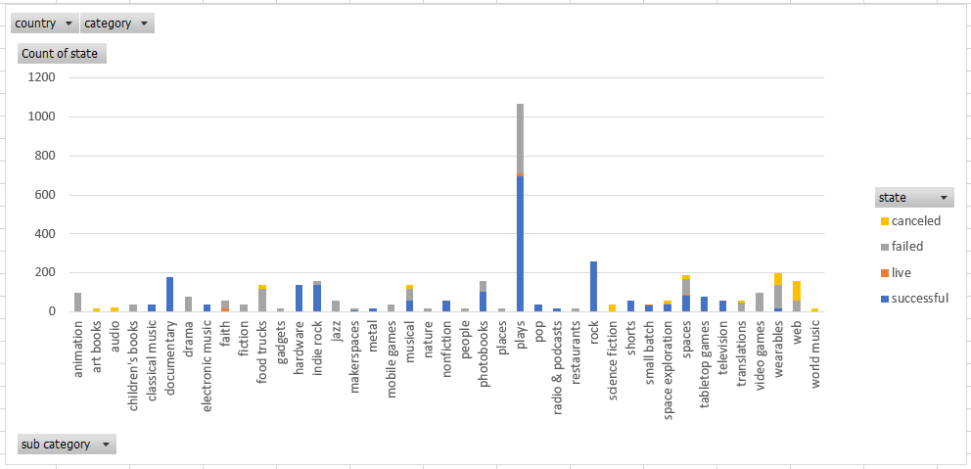

Chart 3

